**Experiment 8**

**Student Name: Husanpreet Kaur UID: 20BCS9512**

**Branch: BE-CSE Section/Group: 20BCS-DM-714/A**

**Semester: 6 Subject Code: 20CSP-376**

**Subject Name: Data Mining Lab Date of Performance: 02-05-2023**

1. **Aim/Overview of the practical:** To perform the hierarchical clustering using R programming.
2. **Tools used:** RStudio
3. **Code:**

library(datasets)

library(cluster)

library(factoextra)

library(purrr)

setwd("C:\\Users\\hp\\Documents\\DATA MINING CODES\\EXPERIMENT 8")

getwd()

df <- mtcars[, 1:5]

df <- na.omit(df)

df <- scale(df)

dismatrix <- dist(df, method="manhattan")

dismatrix

hc <- hclust(dismatrix, method = "single")

plot(hc, cex = 0.5, hang=-1)

cl <- cutree(hc, k=4)

fc <- fviz_cluster(list(data = df, cluster = cl))

fc

plot(hc, cex = 0.5, hang=-1)

rect.hclust(hc, k = 4, border=2:4)

1. **Output:**

RStudio:

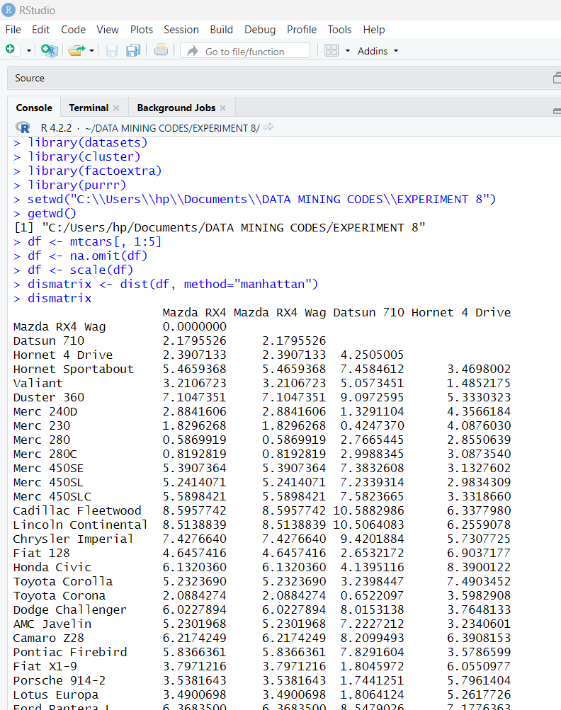

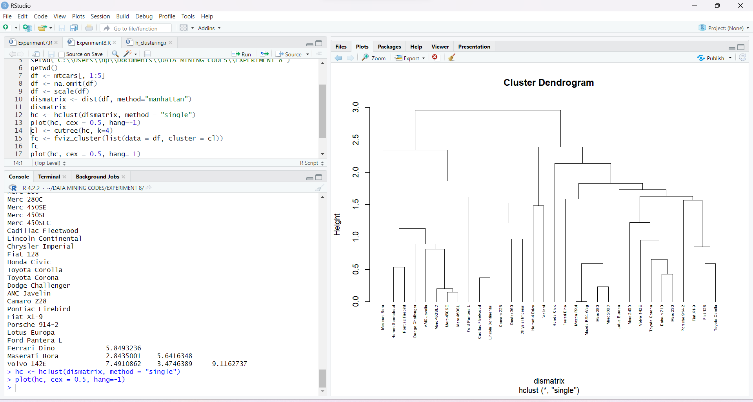

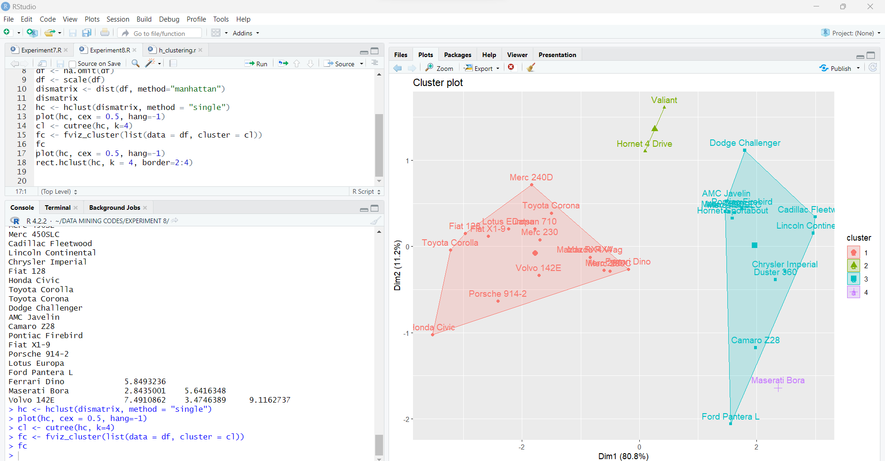

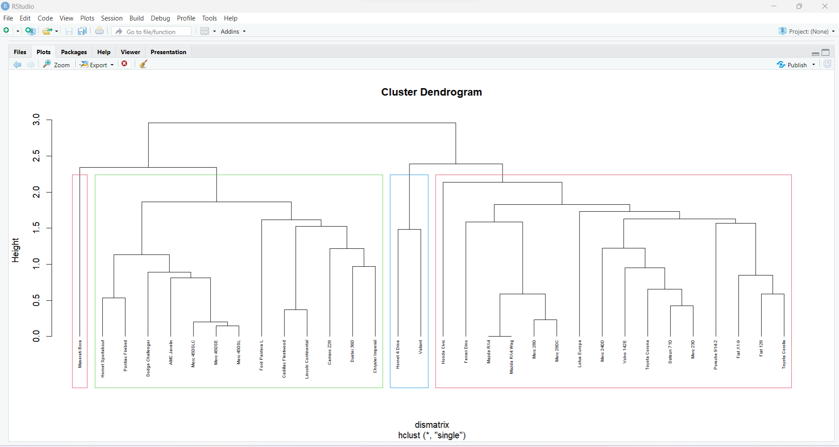

1. **Observation:**

* Learnt how to use R and create a file in Rstudio.
* Learnt how to install packages in Rstudio.
* Learnt how to make clusters and plot data.
* Learnt how to load dataset mtcars with specific columns taken in Rstudio.
* Learnt the use of cluster, factoextra, datsets and purr libraries.
* Learnt how to create dissimilarity matrix.
* Learnt how to cut into clusters using cutree